Instructions for System A:

1. Go to the “SystemA” folder in command prompt.
Note: Close the existing systems before executing the command.
2. Enter “SystemA.bat’.
Note: This will execute “rmic EventManager” command and start the Event manager. If event manager is running, close it before executing the above command.
3. Press enter if needed to start the Environment control system and Security monitoring system.
4. Security monitoring system will be as below. Please follow the instruction in the console to arm and disarm the security.
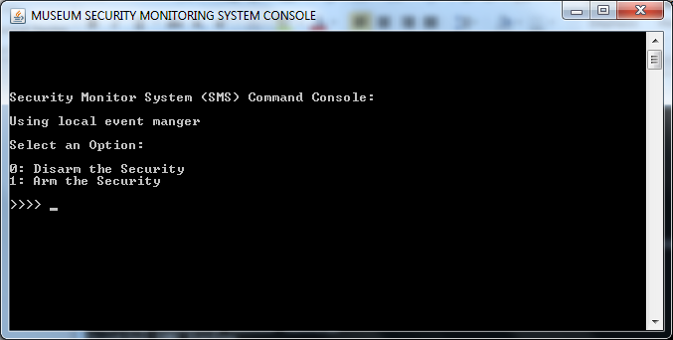

5.Sensors will be as in below format.
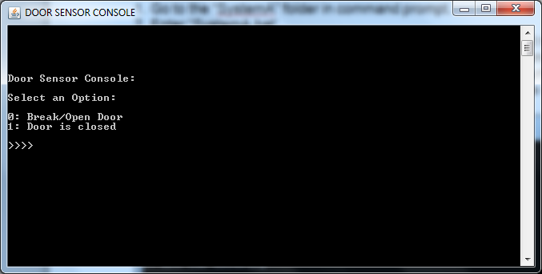
Instructions for System B:

1. Go to the “SystemB” folder in command prompt.
Note: Close the existing systems before executing the command.
2. Enter “SystemB.bat’.
Note: This will execute “rmic EventManager” command and start the Event manager. If event manager is running, close it before executing the above command.
3. Press enter if needed to start the Environment control system and Security monitoring system.
4. Security monitoring system will be as below. Please follow the instruction in the console. To use fire alarm related options use option ‘2’.
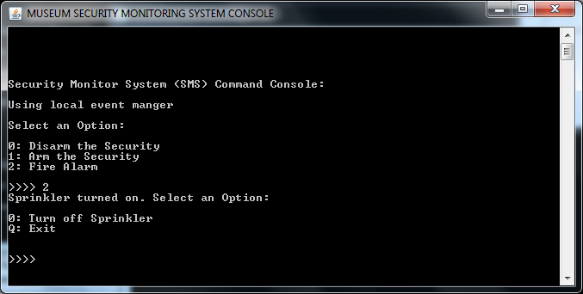

5. Fire Sensor will be as in below format.
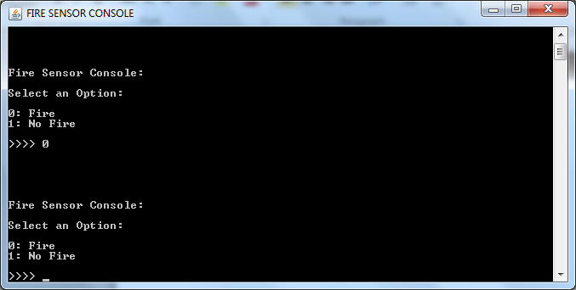

Instructions for System C:

1. Go to the “SystemC” folder in command prompt.
Note: Close the existing systems before executing the command.
2. Enter “SystemC.bat’.
Note: This will execute “rmic EventManager” command and start the Event manager. If event manager is running, close it before executing the above command.
3. Press enter if needed to start the Service Maintenance monitoring system, Environment control system and Security monitoring system.
4. Service Maintenance monitoring system will be as below. Please follow the instruction in the console.
